**The Theme:** Style and Fashion

**Aims:** To provide opportunities to manage reading, understanding, speaking

**Activities:** Students brainstorm with the pictures and the strategies; read, answer the questions, learn quotations, complete the sentences; solve problems, speak and write.

**Visual activities:** AB, slides, records, texts, quotations, pictures, a song. New Opportunities. Education for life. Upper Intermediate. Students' Book. Michael Harris, David Moer, Anna Sikorzinska

**Type of lesson:** Brainstorming

**Plan**

1. Org. moment.
2. Motivation
3. Warming
4. Reading the texts
5. Answering questions
6. Reading and speaking
7. Listening
8. Writing
9. Marks
10. Home task

1. Good morning, dear guests!

Grade 11 “A” greets you.

Hope we will be successful.

We don’t fear.

The teacher will show the way to solve problems.

The teacher gives away the list of new words.

**Vocabulary**

Deal with- иметь дело с…

Impact- влиять

Revealing-выявление откровение

Goths-готы- панки в черном, увлечение - рокн - ролл, происхождение от германского племени, появились в 80ые годы, в Англии, Лондоне

preps- выходцы из Америки, образованная молодежь из богатых семей, предпочитают не работать, а пользоваться состоянием своих родителей, рокн - ролл

Herbs- от слова трава, зависимые от наркотиков

Freak- «уроды, чокнутые» не модные, т. е скромняги

Acceptance- принятие, прием

Rejection-отвержение ч-н., браковка

dye- от слова красить-крашенные

ads-advertisements

Prohibition-запрет/щение

Navel- пупок

Piercing guns- пирсинг мастера

Rebelling - бунтовать

Gear-одежда

Fad-причуда, фантазия

**Music record.**

**Motivation**-read, choose and comment the quotes you agree to prove the theme of the lesson. Fisrt, read silently, then give quotes.

1. Fashion is something we deal with everyday. Even people who say they don't care what they wear choose clothes every morning that say a lot about them and how they feel that day.

One certain thing in the fashion world is change. We are constantly being bombarded with new fashion ideas from music, videos, books, and television. Movies also have a big impact on what people wear. Ray-Ban sold more sunglasses after the movie Men In Black. Sometimes a trend is world-wide. Back in the 1950s, teenagers everywhere dressed like Elvis Presley

1. Go on looking for. Good luck!

Fashion is revealing. Clothes reveal what groups people are in. In high school, groups have names: "Goths, skaters, preps, herbs." Styles show who you are, but they also create stereotypes and distance between groups. For instance, a businessman might look at a boy with green hair and multiple piercings as a freak and outsider. But to another person, the boy is a strict conformist. He dresses a certain way to deliver the message of rebellion and separation, but within that group, the look is uniform. Acceptance or rejection of a style is a reaction to the society we live in. Fashion is a language which tells a story about the person who wears it. "Clothes create a wordless means of communication that we all understand," according to Katherine Hamnett, a top British fashion designer.

**III.** Are you with us?

Fashion is big business. More people are involved in the buying, selling and production of clothing than any other business in the world. Everyday, millions of workers design, sew, glue, dye, and transport clothing to stores. Ads on buses, billboards and magazines give us ideas about what to wear, consciously, or subconsciously. Clothing can be used as a political weapon. In nineteenth century England, laws prohibited people from wearing clothes produced in France. During twentieth century communist revolutions, uniforms were used to abolish class and race distinctions.

**IV.** Let’s make a summary on which we have read.

Простота является лейтмотивом всей истинной элегантности “Simplicity is the keynote of all true elegance.” ― Coco Chanel

Мода меняется, но стиль переживает".

- Коко Шанель

“Fashion changes, but style endures.” ― Coco Chanel

Мода это не то, что существует только в платьях. Мода в небе, на улице, мода имеет дело с идеями, как мы живем, что происходит ". - Коко Шанель

“Fashion is not something that exists in dresses.

Fashion is in the sky, in the street, fashion has to do with ideas, the way we live, what is happening.” – Coco Chanel

**V**.1.Match these captions with the pictures (A-D)  
St’s B.p.29

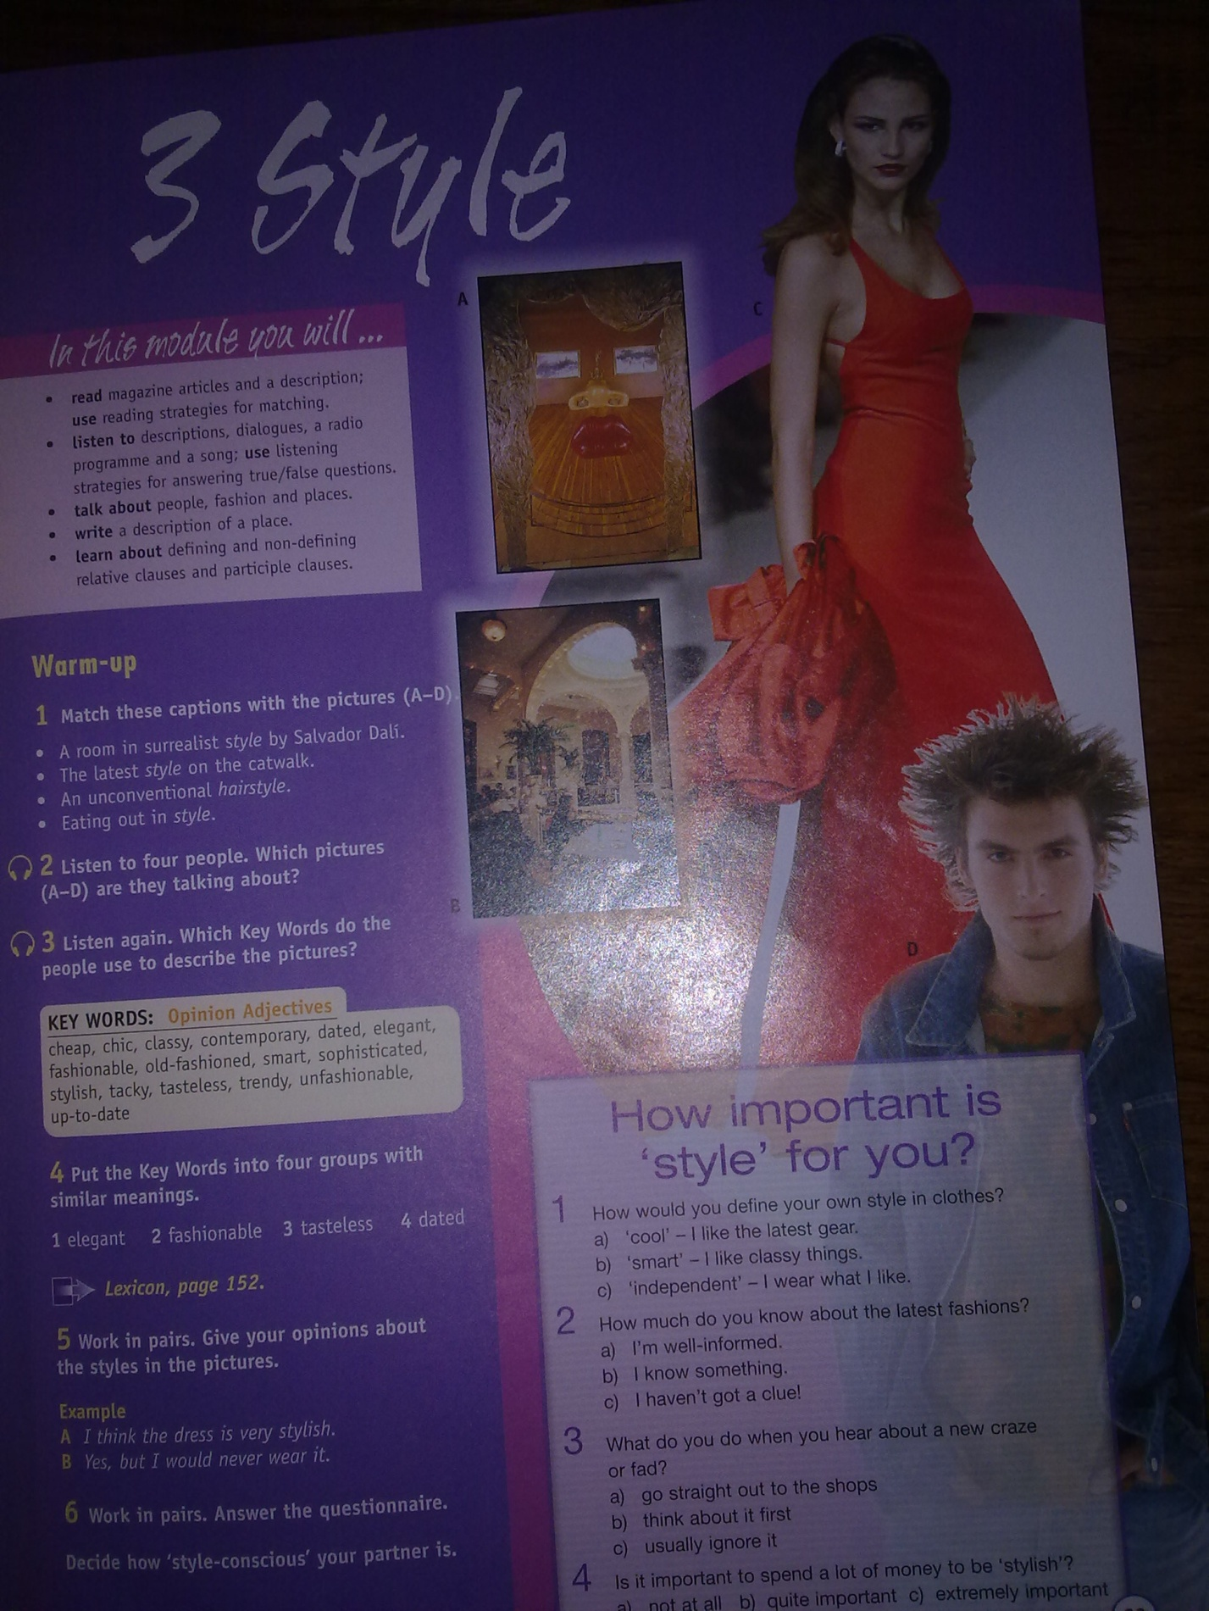

2.Answer the questions

* Would you like to have such room? Why? Why not ?
* Would you like to wear such dress?
* How do you think does eating out in style a part of all people’s life?
* Can everybody have meals at the fashionable restaurants? I think it’s expensive, do you agree ?
* Would you wear such haircut? Do you have any friends who wear such haircut?

**VI.** What can people have done to their body? Ss’B.p.32

**Match the key words to the parts of the body**.

arm, ears, eyebrows, hair,

nails, navel, nose, tongue

**Key words:** dyed, pierced,

shaved, tattooed, varnished

Would you consider having

any of these things done?

**Example:** I might have my hair

dyed one day. But I would never

have my eyebrows pierced

**VII. Read the text and answer the questions**

* Why do some body piercers give the profession a bad name?
* How body piercing go wrong?
* Is body piercing expensive?
* Can you explain why does Lisa say that was a nice professional touch?

**Get sure of your answers**

1. They don’t clean their…
2. People have got diseases like…
3. …$8, …about$35, …$100. I consider it is not cheap but rather…
4. **… the area, …the skin, then he pushed the … through**

**VIII**. If you support these ideas say “Yes”   
if don’t say “No”.

Have you ever met people who have got rings hanging from ears and pushed through noses, lips and eyebrows or on stomachs?

Yes, we can meet such people on TV screens, in magazines, often in western films and it is not exception in our country nowadays.

Some do it for fun. It is common with teenagers.

They think piercing, wearing rings or tattoos are contemporary even cool.

They just think it is Ok. The others may think it is powerful. I think it is tasteless, to say strongly tacky. I wouldn’t harm my body, because it is not natural, not classy, not esthetic.

But tastes differ. It is not worth repeating each culture. And I think

I think, the government should pay attention to this thing.

**IX. We should wear walk men.**

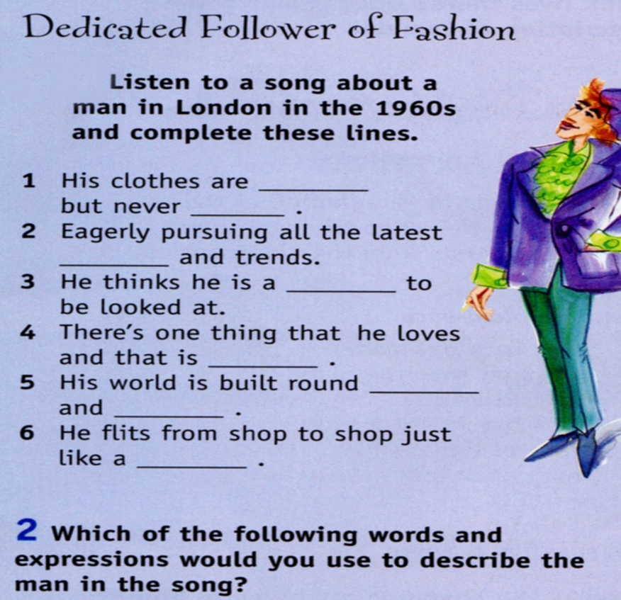

**X. The picture is shown again.** Check yourselves. These are the correct words.  
1.loud/square  
2.fads  
3.flower  
4.flattery  
5.discotheques/parties  
6.butterfly

**XI. Let’s consolidate. Work in groups. One will be a speaker.**

1.**Write a 5 lined poem on the noun you like best**

Piercing

Fashion

Fashioner

Style

2.**Choose a picture. Write a few sentences on the pictures**

**XII. Feedback on the theme**

* What have we talked about?
* What parts of speech have we used to speak on the theme?
* What strategies have we used to speak on the theme?
* Was good at the lesson…

The end.